PURCHASE

1. Shopping cart

Most of the form in purchase / sales has the same repeatable field, it will explained once, more explanation if there are differences.

The form is always has minimum 2 table which has one to many relation.

The shopping cart is purchase document, no execution outside the form

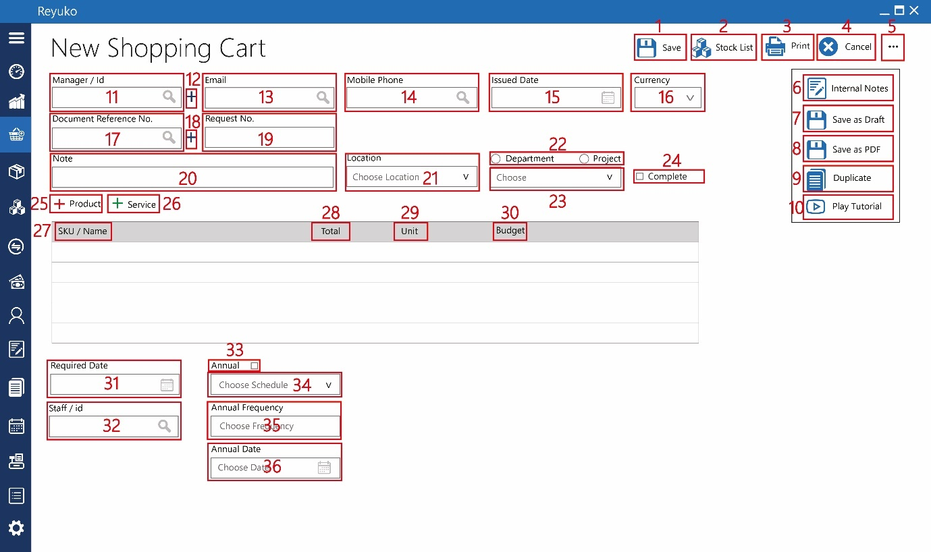

1. Button “save”,
2. Button “stock list”, pop up list which query the list of product from inventory table wwhith the tag location lis on field 21. When field 21 is not filled, it will warning the system to choose the location
3. Button “print”, open print dialog box
4. Button “cancel”, abort
5. Button “…”,
6. Button “internal notes”, triger pop up – simple note form
7. Button “save as draft”, save without posting to other table
8. Button “save as PDF”, optional
9. Button “duplicate”, enabled after save/edit, duplicate the whole form, disable if not saved
10. Button “play tutorial”,
11. Field “manager / ID”, look up to employee/contact table, ajax search
12. Button “+”, triger pop up simple new contact menu (see other form)
13. Field “email”, look up to employee/contact table, ajax search
14. Field “mobile phone”, look up to employee/contact table, ajax search. Field 11,13,14, need only one to search the rest is autofill
15. Datepicker “issued date”, pull down date picker, date of transaction,mandatory
16. dropdown “currency”, look up currency table, by default the primary currency
17. field “document reference no.”, look up document table, ajax search
18. button “+”, triger pop up simple document menu
19. field “request no.”, document number, unique, text,32 characters,by default is using id from the form with min 5 digit number (id 1 = 00001),
20. field “note”, text,255 characters
21. dropdown “location”, look up to location table
22. radio button “department & project”, choose between department / project
23. dropdown “department / project”, look up to location table
24. checkbox “complete”, mark the document form has been follow up, and marked complete
25. button “+product”, switch to product table, product will be marked with the red dot on the table
26. button “+service”, switch to service table, product will be marked with the green dot on the table
27. coloum “SKU/Name”, look up to product table, search ajax base on the sku or product name
28. coloum “total”, input, numbes of product
29. coloum “unit”, autofill base on product selected
30. coloum “budget”, look up to budget table, ajax search the code or account
31. date picker “required date”, pull down date picker
32. Field “staff / id”, look up to employee/contact table, ajax search,

Field 33 to 36, is one procedure to creates template and reminder in the calendar

1. Checkbox “annual”, enable as template and mark on the calendar
2. Dropdown “annual”, pull down option, daily, weekly, monthly, yearly, and undefined. If the undefines selected, the form will be saved as template and mark annual but not save to calendar
3. Field ”annual frequency”, (replace by duration), how many annual will be repeated in the calendar
4. Date picker “annual date”,pull dow date picker, set the time start the annual. The objective is to define how much time the grace periode for the annual start.

|  |  |  |
| --- | --- | --- |
| FIELD TABLE | TABLE | REMARK |
|  | id_permintaan_barang | Unique |
|  | id_kode_transaksi |  |
|  | id_transaksi |  |
|  | kode_transaksi |  |
| Request No. | no_permintaan_barang |  |
|  | id_referal_transaksi |  |
| Manager / Id | id_employee |  |
|  | nama_manajer |  |
| Mobile Phone | no_hp |  |
| Email | email |  |
| Currency | id_mata_uang |  |
|  | mata_uang |  |
|  | kurs_tukar |  |
| Issued Date | tanggal_dibuat |  |
| Document Reference No. | id_no_referensi_dokumen |  |
|  | no_referensi_dokumen |  |
| Location | id_lokasi |  |
|  | Nama_Lokasi |  |
| Note | keterangan |  |
| Project | id_proyek |  |
| Department | id_departemen |  |
| Required Date | tanggal_digunakan |  |
| Staff / id | id_petugas |  |
|  | nama_petugas |  |
| Annual | checkbox_berulang |  |
| Choose Schedule | dropdown_berulang |  |
| Annual Frequency | durasi_berulang |  |
| Annual Date | tanggal_berulang |  |
|  | nilai |  |
|  | id_user_id |  |
| Complete | checkbox_selesai |  |

1. Quotation request

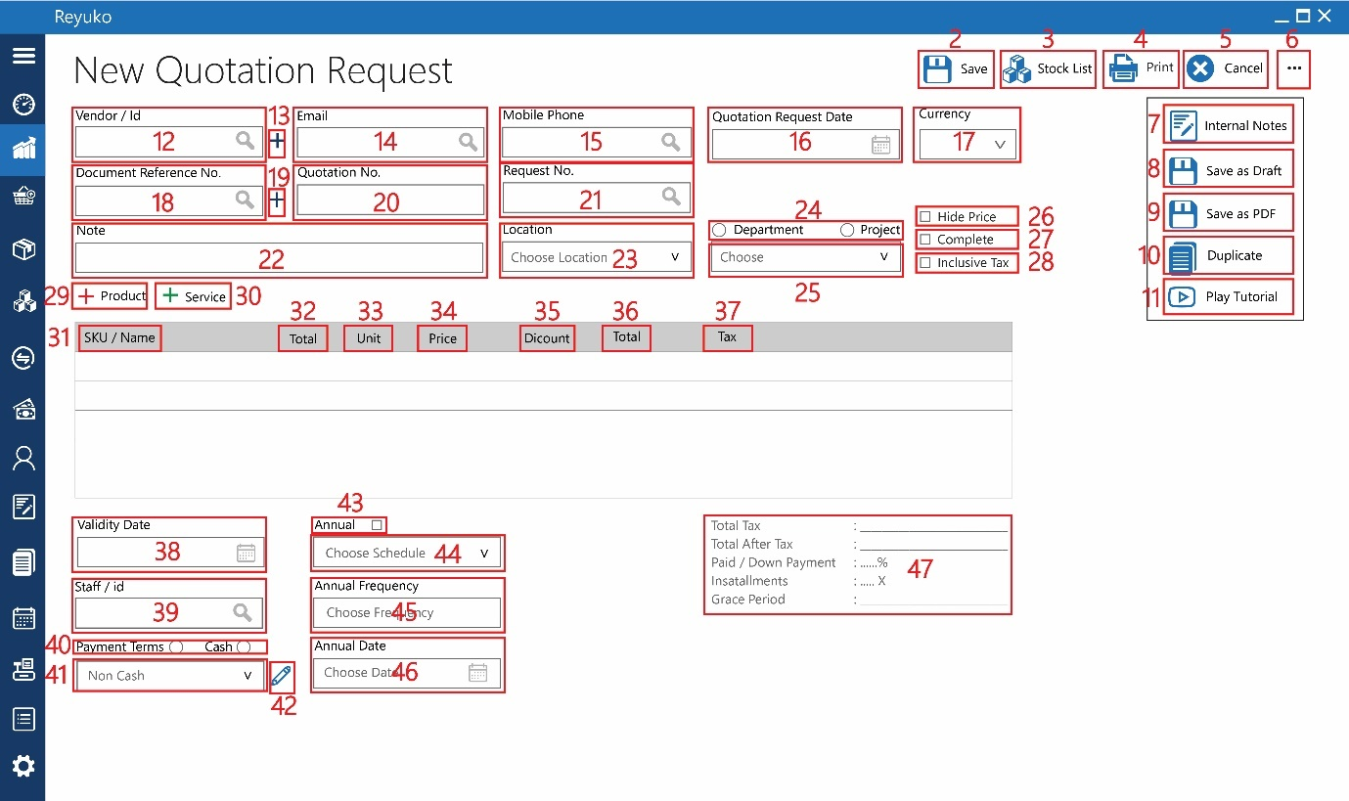

Most of the quotation request is the same with new shopping cart, with the different as follow (highlight green)

1. Button “save”,
2. Button “stock list”,
3. Button “print”,
4. Button “cancel”,
5. Button “…”,
6. Button “internal notes”,
7. Button “save as draft”,
8. Button “save as PDF”, reviewed latter
9. Button “duplicate”,
10. Button “play tutorial”,
11. Field “vendor / ID”,look up to contact vendor/contact, mandatory
12. Button “+”, pop up simple contact/vendor menu
13. Field “email”,
14. Field “mobile phone”,
15. Datepicker “quotation request date”,
16. dropdown “currency”,
17. field “document reference no.”,
18. button “+”,
19. field “quotation no.”,
20. field “request no.”, look up to shopping cart table,field request no. ajax search, if the purchase order will refer from shopping cart, all the document properties will be copied to purchase document : field 17,22-24,29-33
21. field “note”,
22. dropdown “location”,
23. radio button “department & project”,
24. dropdown “department / project”,
25. checkbox “hide price”, hide price, is function in printing where in print document the user can hide the price of the quotation. This document is designed to be viewed by 3rd party, where the owner estimates won’t be shown
26. checkbox “complete”,
27. checkbox “inclusive tax”, if checked, it will recalculate price on coloum 34, with the total still the same. By default the price is not include tax.(New price = Curent price /(1-tax))
28. button “+product”,
29. button “+service”,
30. coloum “SKU/Name”,
31. coloum “total”,
32. coloum “unit”,
33. coloum “price”, currency, look up from product table, “COGS”. Can be overwrite
34. coloum “discount”, manual input, percentage.
35. coloum “total”,
36. coloum “tax”,
37. date picker “validity date”, date picker pull down
38. Field “staff / id”,

Field 40-41, is to create payment terms for sales

1. Radio button “payment term & cash” choose between cash or payment terms which enable payment terms pul down meny
2. Dropdown “payment term/cash”,enable if payment terms selected in field 40, in this form, it will be use scheme name as display. The use of dropdown to instead text is to create seamless user experice with the “sales form” (although in the payment terms there are substantial difference
3. Button “Pencil”, input the terms. ac

The Payment terms pop up is just a record to simplified filling the payment terms. All the record will be fillin the respected table / form

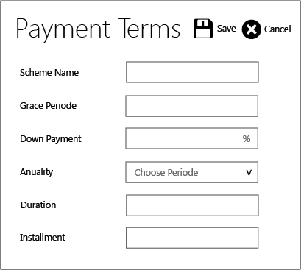

In the quotation request form, scheme will be cash.The payment terms pop up menu only use the down payment, anuality, duration, and installment. The s

* Scheme name, text 32 characters, will be set as display on the dropown, by default the value will be “Payment Terms”
* Grace periode , numbers, date, number of days,weeks, or
* Anuality, option, Daily = 1, weekly=2, monthly=3
* Down payment, percentage, reject is bigger than 100
* Duration, numbers, explained for how many time the terms of payment
* Instalmment, in this form - disable

1. Checkbox “annual”,
2. Dropdown “annual”,
3. Field ”annual frequency”,
4. Date picker “annual date”,
5. Detail, Calculation from the table and payment terms. Please note “due date” will be replaced with grace periode.

The detail will show as follow

Total tax : total tax from the product and service list on table

Total after tax : total cost of the product and service list on table

Down payment : % downpayment (payment terms) x total after tax

Installment : duration (payment terms) x

Grace Periode : grace periode

|  |  |  |
| --- | --- | --- |
| FIELD TABLE | TABLE | REMARK |
|  | id_permintaan_penawaran_harga | unique |
|  | id_kode_transaksi |  |
|  | id_transaksi |  |
|  | kode_transaksi |  |
| Quotation No. | no_permintaan_penawaran_harga |  |
| Vendor / Id | id_vendor |  |
|  | nama_vendor |  |
| Mobile Phone | no_hp |  |
| Email | email |  |
| Request No. | id_permintaan_barang |  |
|  | no_permintaan_barang |  |
|  | id_referal_transaksi |  |
| Currency | id_mata_uang |  |
|  | mata_uang |  |
|  | kurs_tukar |  |
| Quotation Request Date | tanggal_permintaan_penawaran_harga |  |
| Document Reference No. | id_no_referensi_dokumen |  |
|  | no_referensi_dokumen |  |
| Location | id_lokasi |  |
|  | Nama_Lokasi |  |
| Note | keterangan |  |
| Project | id_proyek |  |
| Department | id_departemen |  |
| Inclusive Tax | checkbox_inclusive_tax |  |
| Hide Price | checkbox_hideprice |  |
| Validity Date | tanggal_penutupan |  |
| Staff / id | id_petugas |  |
|  | nama_petugas |  |
| Unposted | checkbox_unposted |  |
| Payment Terms/Cash | checkbox_tunai/term_pembayaran |  |
| Non Cash/Make a Term Payment | dropdown_term_payment | Scheme name – payment terms pop up |
| Grace Periode | grace period | Payment terms pop up |
| Down Payment | uang_muka | Payment terms pop up |
| Anuality | id_opsi_annual | Payment terms pop up |
|  | annual | Payment terms pop up  Daily = 1, weekly=2, monthly=3 |
| Duration | duration | Payment terms pop up |
| Annual | checkbox_berulang |  |
| Choose Schedule | dropdown_berulang |  |
| Annual Frequency | durasi_berulang |  |
| Annual Date | tanggal_berulang |  |
|  | total_order_produk |  |
|  | total_pajak_produk |  |
|  | total_order_jasa |  |
|  | total_pajak_jasa |  |
|  | total_sebelum_pajak |  |
| Total Tax | total_pajak |  |
| Total After Tax | total_setelah_pajak |  |
| Paid/Down Payment | uang_muka |  |
| Installment | angsuran |  |
| Due Date | due_date |  |
|  | id_user_id |  |
|  | id_periode_akuntansi |  |
|  | real_recording_time |  |
| Complete | checkbox_selesai |  |

1. Purchase order

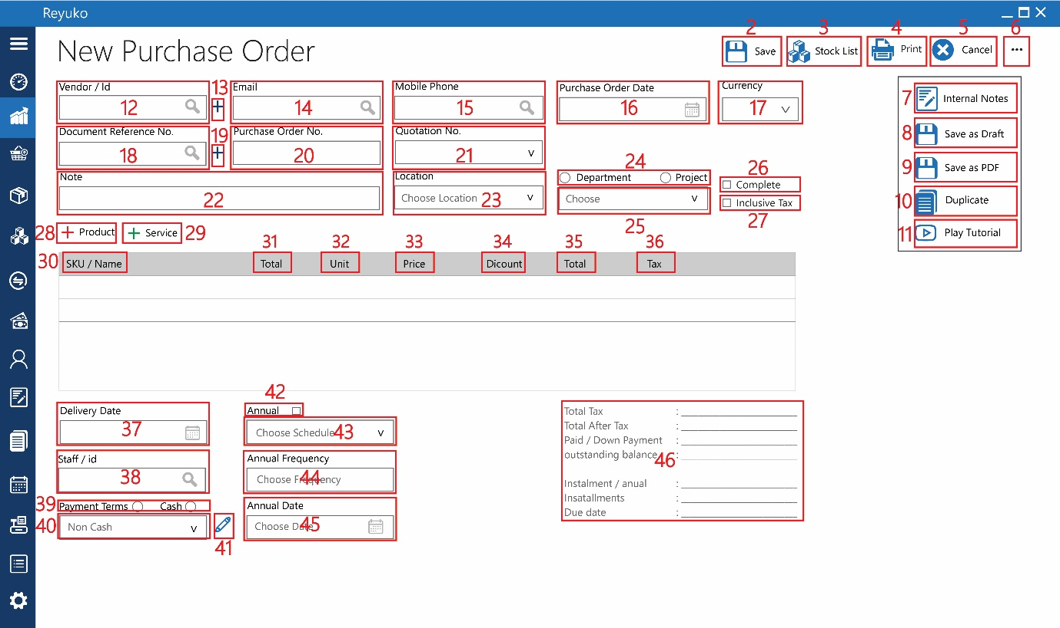

Purchase order is the same with shopping cart and quotation where they are just document and not related to the transaction. The field almost all identical, except payment terms and the field 46, which the result of the payment terms calculation

1. Button “save”,
2. Button “stock list”,
3. Button “print”,
4. Button “cancel”,
5. Button “…”,
6. Button “internal notes”,
7. Button “save as draft”,
8. Button “save as PDF”,
9. Button “duplicate”,
10. Button “play tutorial”,
11. Field “vendor / ID”,
12. Button “+”,
13. Field “email”,
14. Field “mobile phone”,
15. Datepicker “purchase order date”,
16. dropdown “currency”,
17. field “document reference no.”,
18. button “+”,
19. field “purchase order no.”,
20. dropdown “quotation no.”, ajax search (limited to the current vendor), if the purchase order will refer from quotation, all the document properties will be copied to purchase document : 17,22-45 (exclude 26)
21. field “note”,
22. dropdown “location”,
23. radio button “department & project”,
24. dropdown “department / project”,
25. checkbox “complete”,
26. checkbox “inclusive tax”,
27. button “+product”,
28. button “+service”,
29. coloum “SKU/Name”,
30. coloum “total”,
31. coloum “unit”,
32. coloum “price”,
33. coloum “discount”,
34. coloum “total”,
35. coloum “tax”,
36. date picker “delivery date”,
37. Field “staff / id”,
38. Radio button “payment term & cash”
39. Dropdown “payment term/cash”,
40. Button “Pencil”,



In the quotation request form, scheme will be cash.The payment terms pop up menu only use the down payment, anuality, duration, and installment. The s

* Scheme name, text 32 characters, will be set as display on the dropown, by default the value will be “Payment Terms”
* Grace periode , numbers, date, number of days,weeks, or
* Anuality, option, Daily = 1, weekly=2, monthly=3
* Down payment, percentage, reject is bigger than 100
* Duration, numbers, explained for how many time the terms of payment
* Instalment, currency,

1. Checkbox “annual”,
2. Dropdown “annual”,
3. Field ”annual frequency”,
4. Date picker “annual date”,
5. Detail Detail, Calculation from the table and payment terms. Please note “due date” will be replaced with grace periode.The detail will show as follow

Total tax : total tax from the product and service list on table

Total after tax : total cost of the product and service list on table

Down payment : % downpayment (payment terms) x total after tax

Instalment / annual : instalment

Installment : duration (payment terms) x

Due date : date, Delivery date + Grace periode

|  |  |  |
| --- | --- | --- |
| FIELD TABLE | TABLE | REMARK |
|  | id_order_pembelian |  |
|  | id_kode_transaksi |  |
|  | id_transaksi |  |
|  | kode_transaksi |  |
| Purchase Order No. | no_order_pembelian |  |
| Vendor / Id | id_vendor |  |
|  | nama_vendor |  |
| Mobile Phone | no_hp |  |
| Email | email |  |
| Quotation No. | id_permintaan_penawaran_harga |  |
|  | no_permintaan_penawaran_harga |  |
|  | id_referal_transaksi |  |
| Currency | id_mata_uang |  |
|  | mata_uang |  |
|  | kurs_tukar |  |
| Purchase Order Date | tanggal_order_pembelian |  |
| Document Reference No. | id_no_referensi_dokumen |  |
|  | no_referensi_dokumen |  |
| Location | id_lokasi |  |
|  | Nama_Lokasi |  |
| Note | keterangan |  |
| Project | id_proyek |  |
| Department | id_departemen |  |
| Inclusive Tax | checkbox_inclusive_tax |  |
| Delivery Date | tanggal_pengantaran |  |
| Staff / id | id_petugas |  |
|  | nama_petugas |  |
| Unposted | checkbox_unposted |  |
| Payment Terms/Cash | checkbox_tunai/term_pembayaran |  |
| Non Cash/Make a Term Payment | dropdown_term_payment |  |
| Grace Periode | grace period |  |
| Down Payment | uang_muka |  |
| Anuality | id_opsi_annual |  |
|  | annual |  |
| Duration | duration |  |
| Nominal | nominal |  |
| Annual | checkbox_berulang |  |
| Choose Schedule | dropdown_berulang |  |
| Annual Frequency | durasi_berulang |  |
| Annual Date | tanggal_berulang |  |
|  | total_order_produk |  |
|  | total_pajak_produk |  |
|  | total_order_jasa |  |
|  | total_pajak_jasa |  |
|  | total_sebelum_pajak |  |
| Total Tax | total_pajak |  |
| Total After Tax | total_setelah_pajak |  |
| Paid/Down Payment | lunas/uang_muka |  |
| outstanding balance | saldo_terhutang |  |
| Installment/Annual | cicilan_per_bulan |  |
| Installment | angsuran |  |
| Due Date | due_date |  |
|  | id_user_id |  |
|  | id_periode_akutansi |  |
|  | real recording time |  |
| Complete | checkbox_selesai |  |

1. Purchased Document

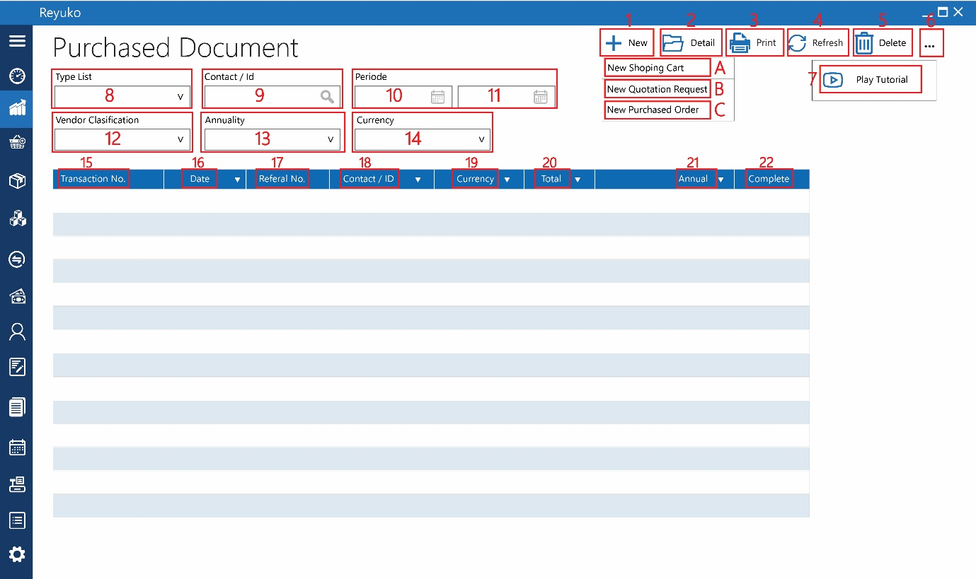

This form is content all purchase document (list sales shopping cart, quotation request, & purchase order)

1. Button “new”, triger new form
2. New shopping cart
3. New quotation request
4. New purchased order
5. Button “detail”, edit or open selected document, same with double click
6. Button “print”, open dialog box for printing
7. Button “refresh”, execute query, if needed
8. Button “delete”, delete selected document
9. Button “…”,
10. Button “play tutorial”,

8-14 is query option for the list

1. Dropdown “type list”, drop down : shopping cart, quotation request, & purchase order
2. Field “contact/id”,
3. Date picker “start periode”, pull down date picker as start date
4. Date picker “end periode”, pull down date picker as end date
5. Dropdown “vendor clasification”, removed
6. Dropdown “annuality”,pull down : all, dayli, monthly, weekly
7. dropdown “currency”, pull down,look up to currency table

informasi tabel

1. transaction no. : document / form number, look up to form shopping cart, quotation request, & purchase order
2. date : date of transaction
3. referral no. : not needed
4. contact / id : look up contact in document form, for shopping cart – manager – employe/contact, for quotation request, & purchase order – vendor/contacct
5. currency : lookup to document currency
6. total : look up to total after tax for quotation request, & purchase order, none for shopping cart
7. annual : look up type of annuality in document form
8. complete : look up complete mark in document form
9. Purchase Delivery :

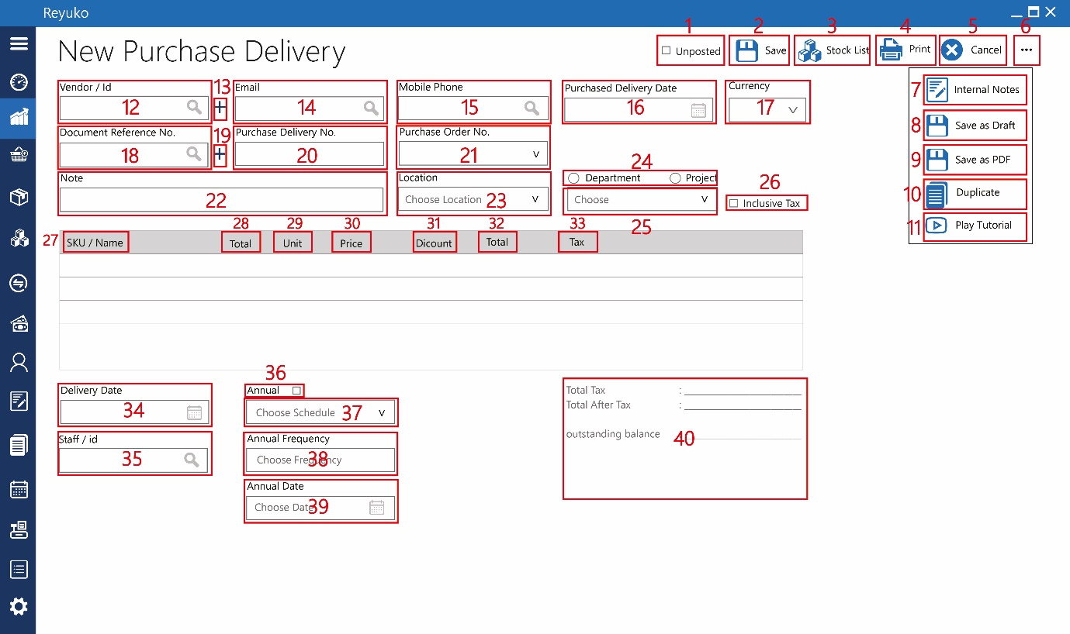

Purchase delivery is transaction form not document like previous 3, all the form function still the same until state otherwise. The form will posting the result to 3 main table : ledger (buku besar table), inventory (order inventori table) and payment modul (modul hutang&piutang table). All transaction provided in excel. All the account lv4 used is define in product and service account setting

1. Checkbox “unposted”, if check, when it is saved, no post to other table, end when editing any posting to other table will be deleted. Other scenario anything table post to ledger, order inentory, and modul hutang-piutang table will marked as unposted, and not being counted for any calculation. Excel table design as 1st scenario
2. Button “save”,
3. Button “stock list”,
4. Button “print”,
5. Button “cancel”,
6. Button “…”,
7. Button “internal notes”,
8. Button “save as draft”,
9. Button “save as PDF”,
10. Button “duplicate”,
11. Button “play tutorial”,
12. Field “vendor / ID”,
13. Button “+”,
14. Field “email”,
15. Field “mobile phone”,
16. Datepicker “purchased delivery date”,
17. dropdown “currency”,
18. field “document reference no.”,
19. button “+”,
20. field “purchase delivery no.”, unique, text, 32 characters
21. field “purchase order no.”, ajax search (limited to the current vendor), if the purchase order will refer from quotation, all the document properties will be copied to purchase document : 17,22-39
22. field “note”,
23. dropdown “location”,
24. radio button “department & project”,
25. dropdown “department / project”,
26. checkbox “inclusive tax”,
27. coloum “SKU/Name”,
28. coloum “total”,
29. coloum “unit”,
30. coloum “price”,
31. coloum “discount”,
32. coloum “total”,
33. coloum “tax”,
34. date picker “delivery date”,
35. Field “staff / id”,
36. Checkbox “annual”,
37. Dropdown “annual”,
38. Field ”annual frequency”,
39. Date picker “annual date”,
40. Detail

Total tax : total tax from the product and service list on table

Total after tax : total cost of the product and service list on table

Outstanding balance : removed

|  |  |  |
| --- | --- | --- |
| FIELD TABLE | TABLE | REMARK |
|  | id_pengiriman_barang_pembelian |  |
|  | id_kode_transaksi |  |
|  | id_transaksi |  |
|  | kode_transaksi |  |
| Purchase Delivery No. | no_pengiriman_barang_pembelian |  |
| Vendor / Id | id_vendor |  |
|  | nama_vendor |  |
| Mobile Phone | no_hp |  |
| Email | email |  |
| Purchase Order No. | id_order_pembelian |  |
|  | no_order_pembelian |  |
|  | id_referal_transaksi |  |
| Currency | id_mata_uang |  |
|  | mata_uang |  |
|  | kurs_tukar |  |
| Delivery Order Date | tanggal_pengiriman_barang_pembelian |  |
| Document Reference No. | id_no_referensi_dokumen |  |
|  | no_referensi_dokumen |  |
| Location | id_lokasi |  |
|  | Nama_Lokasi |  |
| Note | keterangan |  |
| Project | id_proyek |  |
| Department | id_departemen |  |
| Inclusive Tax | checkbox_inclusive_tax |  |
| Delivery Date | tanggal_pengantaran |  |
| Staff / id | id_petugas |  |
|  | nama_petugas |  |
| Unposted | checkbox_unposted |  |
| Payment Terms/Cash | checkbox_tunai/term_pembayaran |  |
| Non Cash/Make a Term Payment | dropdown_term_payment |  |
| Grace Periode | grace period |  |
| Down Payment | uang_muka |  |
| Anuality | id_opsi_annual |  |
|  | annual |  |
| Duration | duration |  |
| Nominal | nominal |  |
| Annual | checkbox_berulang |  |
| Choose Schedule | dropdown_berulang |  |
| Annual Frequency | durasi_berulang |  |
| Annual Date | tanggal_berulang |  |
|  | akun_persediaan_produk |  |
|  | total_debit_akun_persediaan_produk |  |
|  | total_kredit_akun_persediaan_produk |  |
|  | akun_pengiriman_beli_produk |  |
|  | total_debit_akun_pengiriman_beli_produk |  |
|  | total_kredit_akun_pengiriman_beli_produk |  |
|  | total_sebelum_pajak |  |
| Total Tax | total_pajak |  |
| Total After Tax | total_setelah_pajak |  |
| outstanding balance | saldo_terhutang |  |
|  | id_user_id |  |
|  | id_periode_akuntansi |  |
|  | real recording time |  |

1. List Purchase Delivery

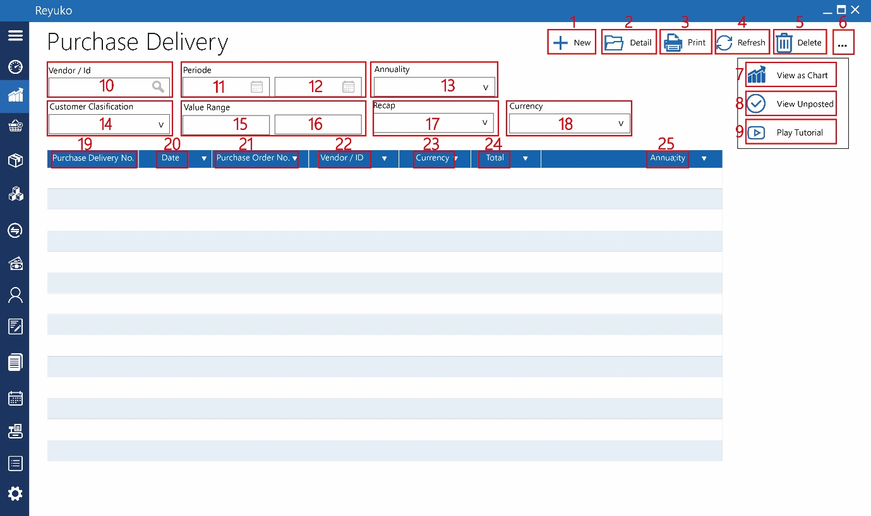

1. Button “new”,
2. Button “detail”,
3. Button “print”,
4. Button “refresh”,
5. Button “delete”,
6. Button “…”,
7. Button “view as chart”, triger pop up chart which represent the recap menu data value, disable if no recap query execute
8. Button “view unposted”,
9. Button “play tutorial”,
10. Field “vendor/id”,
11. Date picker “start periode”,
12. Date picker “end periode”,
13. Dropdown “annuality”,
14. Dropdown “customer clasification”,
15. Field “start value range”, currency, low range value
16. Field “end value range”, currency, high range value, if not start > end, rejected.
17. dropdown “recap”, pull down daily, monthly, yearly, recap the value of delivery order in time base if excuted. (see the printing and recap document)
18. dropdown “currency”,

informasi tabel

1. purchase delivery no. :
2. date :
3. purchase order no. :
4. vendor / id :
5. currency :
6. total :
7. annual :
8. received goods

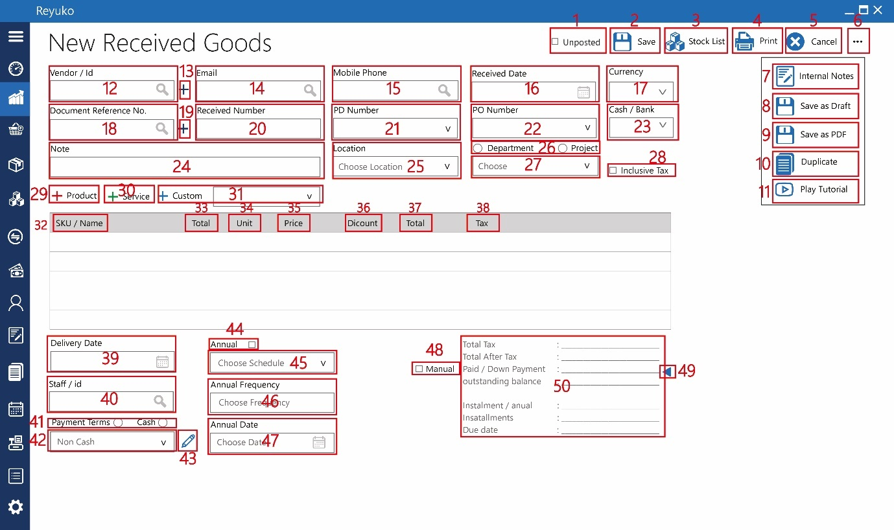

Receive goods is transaction form like purchase deliver, all the form function still the same until state otherwise. The form will posting the result to 3 main table : ledger (buku besar table), inventory (order inventori table) and payment modul (modul hutang&piutang table). All transaction provided in excel. All the account lv4 used is define in product and service account setting (including custom – not define yet in the document). The difference is in 41-42 (which the same with previous document) and 48-50

1. Checkbox “unposted”,
2. Button “save”,
3. Button “stock list”,
4. Button “print”,
5. Button “cancel”,
6. Button “…”,
7. Button “internal notes”,
8. Button “save as draft”,
9. Button “save as PDF”,
10. Button “duplicate”,
11. Button “play tutorial”,
12. Field “vendor / ID”,
13. Button “+”,
14. Field “email”,
15. Field “mobile phone”,
16. Datepicker “received date”,
17. dropdown “currency”,
18. field “document reference no.”,
19. button “+”,
20. field “received no.”,
21. field “PD number”, ajax search, pull down, look up to Purchase delivery table, field document number, if PD already refer to PO number, automatically fill PO number.optional
22. field “PO number”, ajax search, pull down, look up to Purchase order table. optional
23. dropdown “cash/bank”, list of account lv4 with the cash/bank marked enable
24. field “note”,
25. dropdown “location”,
26. radio button “department & project”,
27. dropdown “department / project”,
28. checkbox “inclusive tax”,
29. button “+product”,
30. button “+service”,
31. button & dropdown “+custom”, creates new line outsides product and service which the manually input. To enable this feature user has to selected list account L4 which list in the pull down. By default it will using default account specified “Custom Service”
32. coloum “SKU/Name”,
33. coloum “total”,
34. coloum “unit”,
35. coloum “price”,
36. coloum “discount”,
37. coloum “total”,
38. coloum “tax”,
39. date picker “delivery date”,
40. Field “staff / id”,
41. Radio button “payment term & cash”
42. Dropdown “payment term/cash”,
43. Button “pencil”,
44. Checkbox “annual”,
45. Dropdown “annual”,
46. Field ”annual frequency”,
47. Date picker “annual date”,

Field 48-40 is used to make down payment (optional process)

1. Checkbox “manual”, enabling to put manually down payment.
2. Button “down payment”, if click will triger pop up containing the outstanding balance from the respective vendor. When selected, the selection will display as currency. If manual being selected, the field will become input, currency. When terms is used, the down payment will use the calculation from the terms.
3. Detail, due to payment terms, down payment, and transaction table, the detail will see as follow :

Total tax : total tax from the product and service list on table

Total after tax : total cost of the product and service list on table

Down payment : % downpayment (payment terms) x total after tax. Or manually input. Or selected from list of vendor’s outstanding balance

Outstanding balance: Total after tax

Instalment / annual : instalment

Installment : duration (payment terms) x

Due date : date, Delivery date + Grace periode

|  |  |  |
| --- | --- | --- |
| FIELD TABLE | TABLE | REMARK |
|  | id_order | unique |
|  | id_kode_transaksi |  |
|  | id_transaksi |  |
|  | kode_transaksi |  |
| Received Number | no_order |  |
| Vendor / Id | id_vendor |  |
|  | nama_vendor |  |
| Mobile Phone | no_hp |  |
| Email | email |  |
|  | id_order_pembelian |  |
| PO Number | no_order_pembelian |  |
|  | id_PD |  |
| PD Number | no_PD |  |
|  | id_referal_transaksi |  |
| Currency | id_mata_uang |  |
|  | mata_uang |  |
|  | kurs_tukar |  |
| Received Date | tanggal_order |  |
| Document Reference No. | id_no_referensi_dokumen |  |
|  | no_referensi_dokumen_NI |  |
| Location | id_lokasi |  |
|  | Nama_Lokasi |  |
| Note | keterangan |  |
| Project | id_proyek |  |
| Department | id_departemen |  |
| Inclusive Tax | checkbox_inclusive_tax |  |
| Delivery Date | tanggal_pengiriman |  |
| Staff / id | id_petugas |  |
|  | nama_petugas |  |
| Unposted | checkbox_unposted |  |
| Payment Terms/Cash | checkbox_tunai/term_pembayaran |  |
| Non Cash/Make a Term Payment | dropdown_term_payment |  |
| Grace Periode | grace period |  |
| Down Payment | uang_muka |  |
| Anuality | id_opsi_annual |  |
|  | annual |  |
| Duration | duration |  |
| Nominal | nominal |  |
| Cash / Bank | dropdown_bank_kas |  |
| Annual | checkbox_berulang |  |
| Choose Schedule | dropdown_berulang |  |
| Annual Frequency | durasi_berulang |  |
| Annual Date | tanggal_berulang |  |
|  | id_akun_persediaan_produk |  |
|  | total_debit_akun_persediaan_produk |  |
|  | total_kredit_akun_persediaan_produk |  |
|  | id_akun_pengiriman_beli_produk |  |
|  | total_debit_akun_pengiriman_beli_produk |  |
|  | total_kredit_akun_pengiriman_beli_produk |  |
|  | id_akun_pembelian_jasa |  |
|  | total_debit_pembelian_jasa |  |
|  | total_kredit_pembelian_jasa |  |
|  | id_akun_pembelian_custom |  |
|  | total_debit_pembelian_custom |  |
|  | total_kredit_pembelian_custom |  |
|  | id_akun_pajak_produk |  |
|  | total_debit_akun_pajak_produk |  |
|  | total_kredit_akun_pajak_produk |  |
|  | id_akun_pajak_jasa |  |
|  | total_debit_akun_pajak_jasa |  |
|  | total_kredit_akun_pajak_jasa |  |
|  | id_akun_tunai_pembelian |  |
|  | total_debit_akun_tunai_pembelian |  |
|  | total_kredit_akun_tunai_pembelian |  |
|  | id_akun_hutang_pembelian |  |
|  | total_debit_akun_hutang_pembelian |  |
|  | total_kredit_akun_hutang_pembelian |  |
|  |  |  |
|  | total_sebelum_pajak |  |
| Total Tax | total_pajak |  |
| Total After Tax | total_setelah_pajak |  |
| Manual | Checkbox_Manual |  |
|  | id_referal_PA |  |
| Paid/Down Payment | lunas/dibayar_uang_muka |  |
| outstanding balance | saldo_terhutang |  |
| Installment/Annual | cicilan_per_bulan |  |
| Installment | angsuran |  |
| Due Date | due_date |  |
|  | id_user_id |  |
|  | id_periode_akuntansi |  |
|  | real recording time |  |

1. List received goods

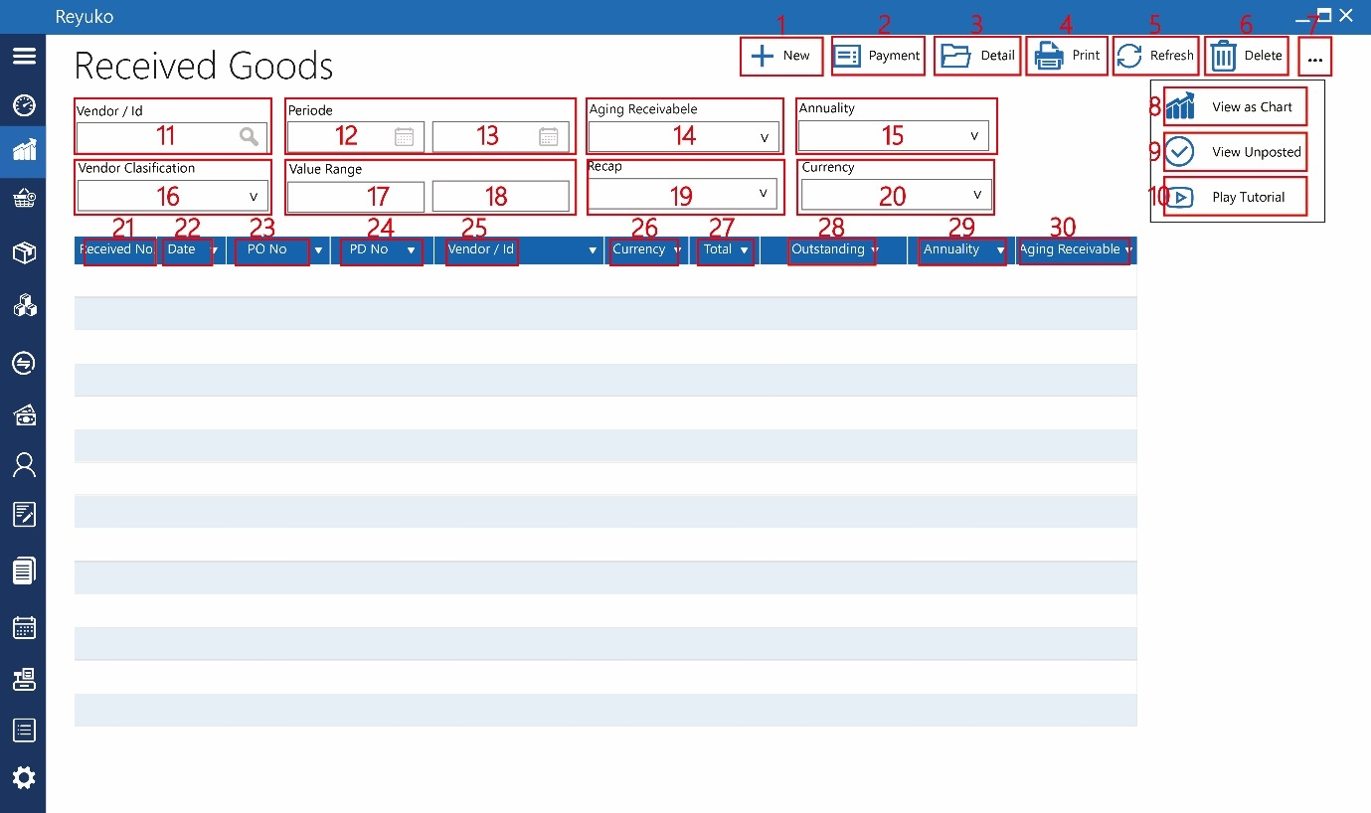

All the same with Purchase delivery, with the differentiate fiel 21,22,23 which is about document numbes.

1. Button “new”,
2. Button “payment”,
3. Button “detail”,
4. Button “print”,
5. Button “refresh”,
6. Button “delete”,
7. Button “…”,
8. Button “view as chart”,
9. Button “view unposted”,
10. Button “play tutorial”,
11. Field “vendor/id”,
12. Date picker “start periode”,
13. Date picker “end periode”,
14. Dropdown “aging receivable”,
15. Dropdown “annuality”,
16. Dropdown “customer clasification”,
17. Field “start value range”,
18. Field “end value range”,
19. dropdown “recap”,
20. dropdown “currency”,

informasi tabel

1. received no. : look up to receive goods table
2. date :
3. PO no. : look up to purchase order table
4. PD no : look up to purchase delivery table
5. vendor / id :
6. currency :
7. total :
8. outstanding
9. annuality :
10. aging receivable
11. purchase Return

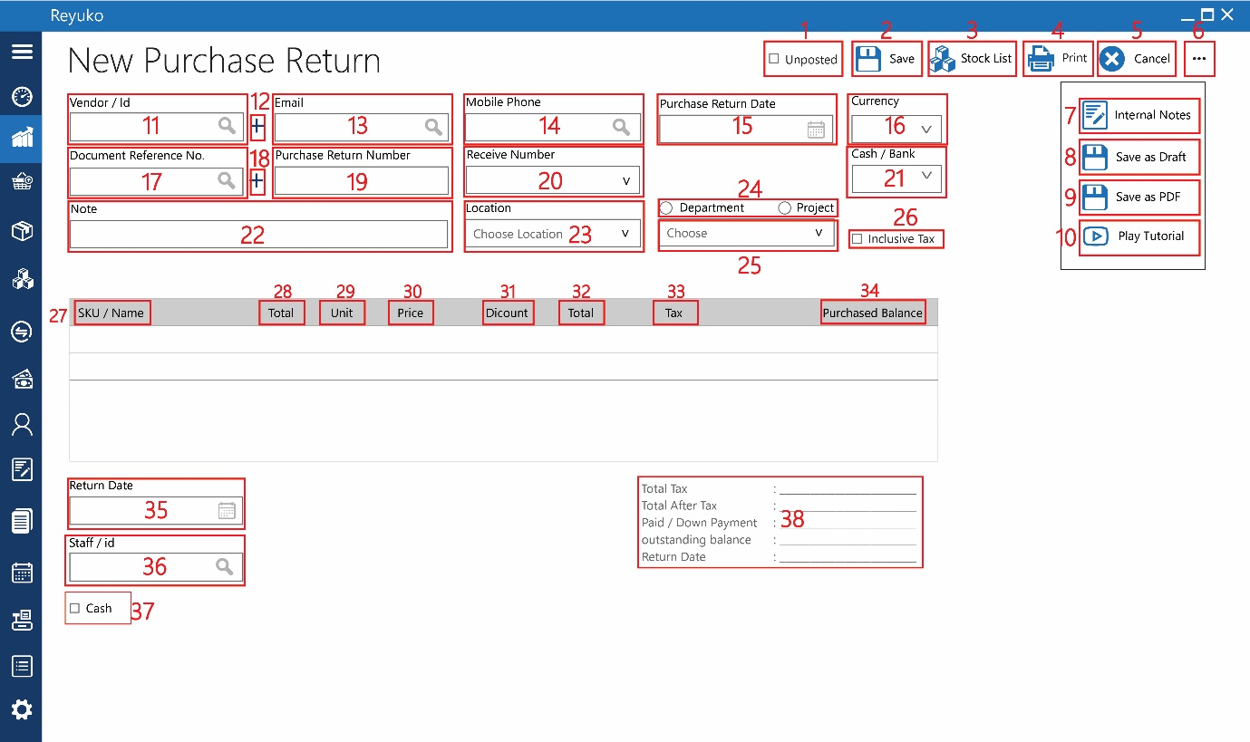

Purchase return is basically editing the receive goods by reducing the product/service used. Field 20 is mandory

1. Checkbox “unposted”,
2. Button “save”,
3. Button “stock list”,
4. Button “print”,
5. Button “cancel”,
6. Button “…”,
7. Button “internal notes”,
8. Button “save as draft”,
9. Button “save as PDF”,
10. Button “play tutorial”,
11. Field “vendor / ID”,
12. Button “+”,
13. Field “email”,
14. Field “mobile phone”,
15. Datepicker “purchase return date”,
16. dropdown “currency”,
17. field “document reference no.”,
18. button “+”,
19. field “purchase return no.”,
20. dropdown “receive number”, look up to product receive table, it is mandatory in this form, when selected, all the receive product document will preload
21. dropdown “cash/bank”,
22. field “note”,
23. dropdown “location”,
24. radio button “department & project”,
25. dropdown “department / project”,
26. checkbox “inclusive tax”,
27. coloum “SKU/Name”,
28. coloum “total”,
29. coloum “unit”, by default is already filled by referring to purchase receive (it means full unit will be returned, but can be over write for lower unit – bigger rejected. (or with (-) button in the side)
30. coloum “price”,
31. coloum “discount”,
32. coloum “total”,
33. coloum “tax”,
34. coloum “purchased balance”, by default it value = 0,counterpart field 35+36, when unit become 0, the balance = 35+36 or base on the number product reduction (or it means no product return)
35. date picker “delivery date”, replace with return date, pull down date picker
36. Field “staff / id”,

Installment for returns

1. Radio button “payment term & cash” replace by check box cash, if checked will used cash transaction, otherwise will be treated as outstanding balance
2. Detail, recalculate everything

Total tax : total tax from the product and service return

Total after tax : total cost of the product and service return

Paid/Down payment : Total being paid from payment modul (modul hutang&piutang table)

Outstanding balance: paid/down payment – total outstanding purchase. If plus (+) the outstanding will be set as payment obligation (if cash enabled (field 40), direct to reduce cash, if not checked will set as outstanding payment). If negative (-), the total outstanding from the vendor will be adjusted to the value of negative by eliminating the surplus the last outstanding value. The value of adjustemn is (current value outstanding – outstanding balance) and adjusted to the last term of obligation (if there’s an instalment, if not deduct the amount directly)

Return date : return date

|  |  |  |
| --- | --- | --- |
| FIELD TABLE | TABLE | REMARK |
|  | id_retur_pembelian | unique |
|  | id_kode_transaksi |  |
|  | id_transaksi |  |
|  | kode_transaksi |  |
| Purchase Return Number | no_retur_pembelian |  |
| Vendor / Id | id_vendor |  |
|  | nama_vendor |  |
| Mobile Phone | no_hp |  |
| Email | email |  |
| Receive Number | id_referal_transaksi |  |
|  | no_referensi_transaksi |  |
|  | id_referal_transaksi |  |
| Currency | id_mata_uang |  |
|  | mata_uang |  |
|  | kurs_tukar |  |
| Received Date | tanggal_retur_pembelian |  |
| Document Reference No. | id_no_referensi_dokumen |  |
|  | no_referensi_dokumen |  |
| Location | id_lokasi |  |
|  | Nama_Lokasi |  |
| Note | keterangan |  |
| Project | id_proyek |  |
| Department | id_departemen |  |
| Inclusive Tax | checkbox_inclusive_tax |  |
| Delivery Date | tanggal_pengiriman |  |
| Staff / id | id_petugas |  |
|  | nama_petugas |  |
| Unposted | checkbox_unposted |  |
| Payment Terms / Cash | checkbox_tunai/term_pembayaran |  |
| Choose Terms | dropdown_term_pembayaran |  |
| Cash / Bank | dropdown_bank_kas |  |
|  | id_akun_persediaan_produk |  |
|  | total_debit_akun_persediaan_produk |  |
|  | total_kredit_akun_persediaan_produk |  |
|  | id_akun_pembelian_jasa |  |
|  | total_debit_pembelian_jasa |  |
|  | total_kredit_pembelian_jasa |  |
|  | id_akun_pembelian_custom |  |
|  | total_debit_pembelian_custom |  |
|  | total_kredit_pembelian_custom |  |
|  | id_akun_pajak_produk |  |
|  | total_debit_akun_pajak_produk |  |
|  | total_kredit_akun_pajak_produk |  |
|  | id_akun_pajak_jasa |  |
|  | total_debit_akun_pajak_jasa |  |
|  | total_kredit_akun_pajak_jasa |  |
|  | id_akun_tunai_pembelian |  |
|  | total_debit_akun_tunai_pembelian |  |
|  | total_kredit_akun_tunai_pembelian |  |
|  | id_akun_hutang_pembelian |  |
|  | total_debit_akun_hutang_pembelian |  |
|  | total_kredit_akun_hutang_pembelian |  |
|  | total_sebelum_pajak |  |
| Total Tax | total_pajak |  |
| Total After Tax | total_setelah_pajak |  |
| outstanding balance | saldo_piutang |  |
|  | cicilan_per_bulan |  |
|  | angsuran |  |
|  | due_date |  |
|  | id_user_id |  |
|  | id_periode_akuntansi |  |
|  | real recording time |  |

1. List purchase return

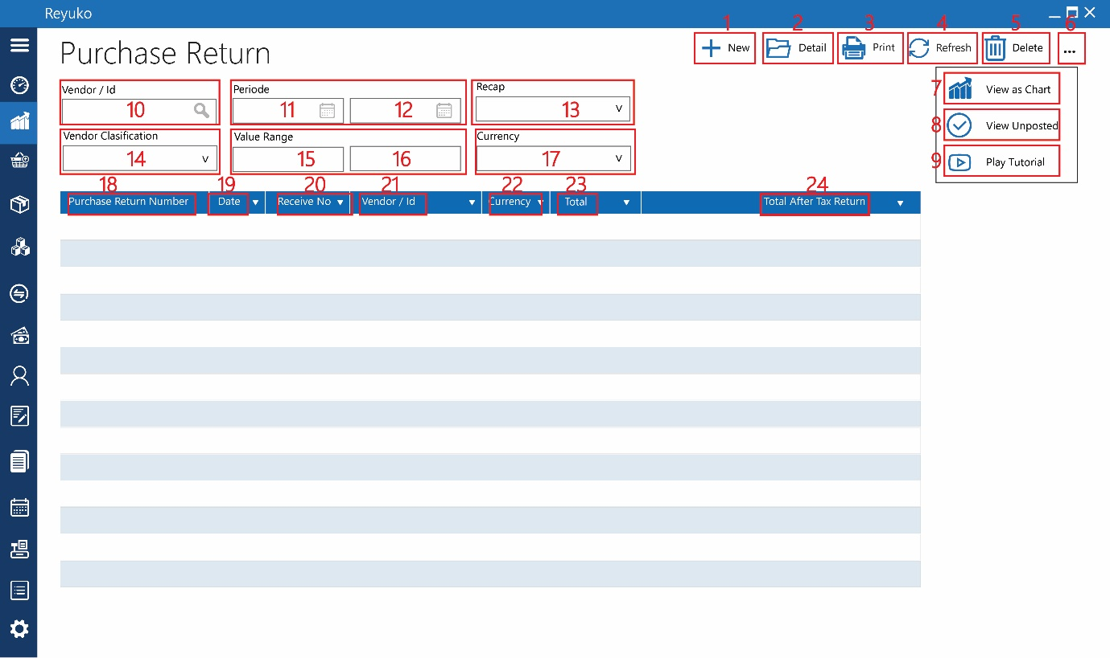

The same with purchase list only state otherwise

1. Button “new”,
2. Button “detail”,
3. Button “print”,
4. Button “refresh”,
5. Button “delete”,
6. Button “…”,
7. Button “view as chart”,
8. Button “view unposted”,
9. Button “play tutorial”,
10. Field “vendor/id”,
11. Date picker “start periode”,
12. Date picker “end periode”,
13. Dropdown “recap”,
14. Dropdown “vendor clasification”,
15. Field “start value range”,
16. Field “end value range”,
17. dropdown “currency”,

informasi tabel

1. purchase return no. :
2. date :
3. receive no. :
4. vendor / id :
5. currency :
6. total :
7. Total After Tax Return :

# SALES

All the sales is identical with purchase document, except,

* Debit become credit, credit become debit.
* Payment term in purchase is unique per transaction, in sales it is base on payment terms table.

1. Sales quotation

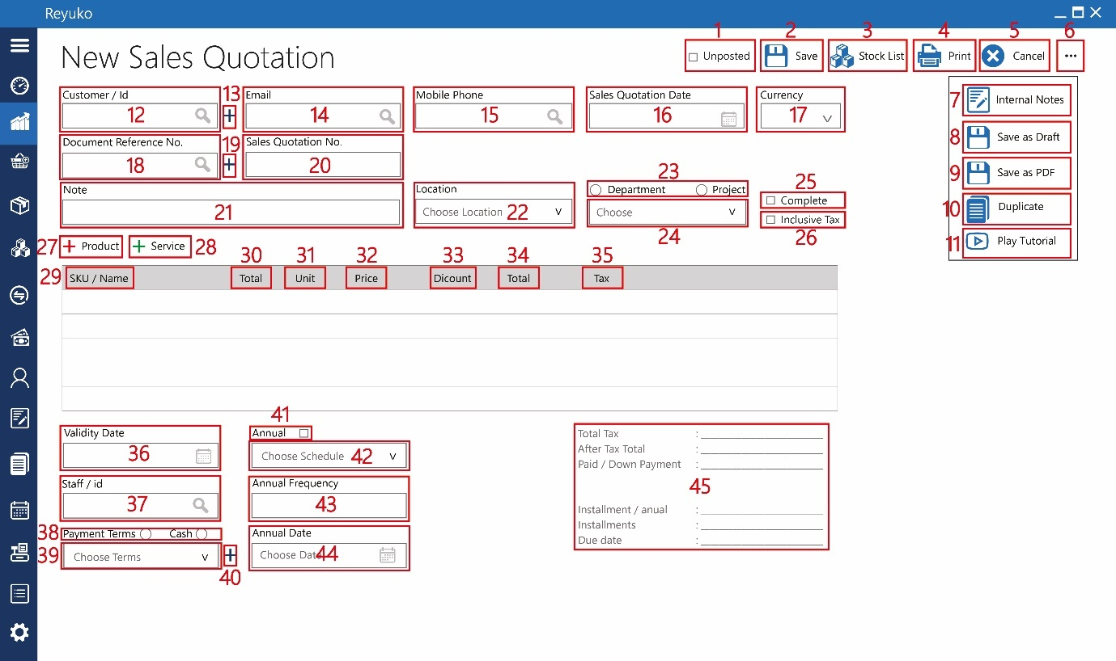

The form is the reverse of request fot quotation, with the different in “hide price option” and pament terms option

1. Checkbox “unposted”, removed
2. Button “save”,
3. Button “stock list”,
4. Button “print”,
5. Button “cancel”,
6. Button “…”,
7. Button “internal notes”,
8. Button “save as draft”,
9. Button “save as PDF”,
10. Button “duplicate”,
11. Button “play tutorial”,
12. Field “customer / ID”,
13. Button “+”,
14. Field “email”,
15. Field “mobile phone”,
16. Datepicker “sales quotatin date”,
17. dropdown “currency”,
18. field “document reference no.”,
19. button “+”,
20. field “sales quotation no.”,
21. field “note”,
22. dropdown “location”,
23. radio button “department & project”,
24. dropdown “department / project”,
25. checkbox “complete”,
26. checkbox “inclusive tax”,
27. button “+product”,
28. button “+service”,
29. kolom “SKU/Name”,
30. kolom “total”,
31. kolom “unit”,
32. kolom “price”,
33. kolom “discount”,
34. kolom “total”,
35. kolom “tax”,
36. date picker “validity date”,
37. Field “staff / id”,

Payment terms optiom

1. Radio button “payment term & cash” choose between using payment terms or option, by default is cash
2. Dropdown “payment term/cash”, look up to payment terms table, pull down.
3. Button “+”, add another payment terms

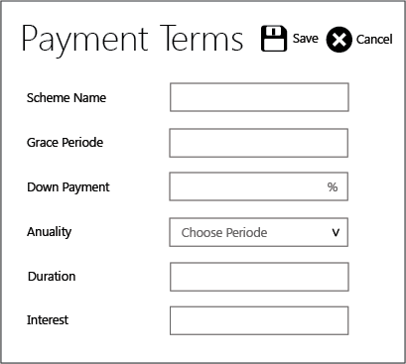

* Scheme name, text 32 characters, will be set as display on the dropown, by default the value will be “Payment Terms n” reject if the same
* Grace periode , numbers, date, number of days,weeks, or month
* Anuality, option, Daily = 1, weekly=2, monthly=3
* Down payment, percentage, reject is bigger than 100
* Duration, numbers, explained for how many time the terms of payment
* Interest, percetage

1. Checkbox “annual”,
2. Dropdown “annual”,
3. Field ”annual frequency”,
4. Date picker “annual date”,
5. Detail

Total tax : total tax from the product and service list on table

Total after tax : total cost of the product and service list on table

Down payment : % downpayment (payment terms) x total after tax.

Outstanding balance: Total after tax

Instalment / annual : instalment

Installment : duration (payment terms) x

Due date : date, Delivery date + Grace periode

|  |  |  |
| --- | --- | --- |
| FIELD TABLE | TABLE | REMARK |
|  | id_penawaran_harga |  |
|  | id_kode_transaksi |  |
|  | id_transaksi |  |
|  | kode_transaksi |  |
| Sales Quotation No. | no_penawaran_harga |  |
|  | id_referal_transaksi |  |
| customer / id | id_kontak |  |
|  | nama_pelanggan |  |
| mobile phone | no_hp |  |
| email | email |  |
| currency | id_mata_uang |  |
|  | mata_uang |  |
|  | kurs_tukar |  |
| Sales Quotation Date | tanggal_penawaran_harga |  |
| Document Reference No. | id_no_referensi_dokumen |  |
|  | no_referensi_dokumen |  |
| Location | id_lokasi |  |
|  | Nama_Lokasi |  |
| Note | keterangan |  |
| Project | id_proyek |  |
| Department | id_departemen |  |
| Inclusive Tax | checkbox_inclusive_tax |  |
| Validity Date | tanggal_penutupan |  |
| Staff / id | id_petugas |  |
|  | nama_petugas |  |
| Unposted | checkbox_unposted |  |
| Payment Terms / Cash | checkbox_tunai/term_pembayaran |  |
| Choose Terms | dropdown_term_pembayaran |  |
| Annual | checkbox_berulang |  |
| Choose Schedule | dropdown_berulang |  |
| Annual Frequency | durasi_berulang |  |
| Annual Date | tanggal_berulang |  |
|  | total_order_produk |  |
|  | total_pajak_produk |  |
|  | total_order_jasa |  |
|  | total_pajak_jasa |  |
|  | total_sebelum_pajak |  |
| Total Tax | total_pajak |  |
| After Total Tax | total_setelah_pajak |  |
| paid/down payment | lunas/uang_muka |  |
| Installment/Annual | cicilan_per_bulan |  |
| Installment | durasi_cicilan |  |
| Due Date | due_date |  |
|  | id_user_id |  |
|  | id_periode_akutansi |  |
|  | real recording time |  |
| Complete | checkbox_selesai |  |

1. Sales Order

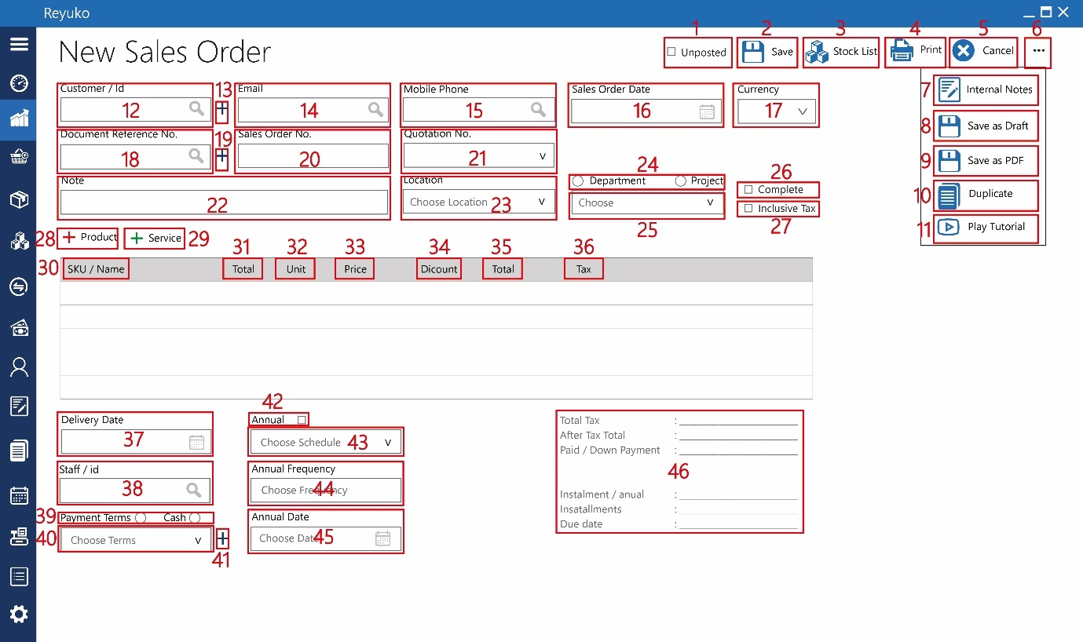

1. Checkbox “unposted”,
2. Button “save”,
3. Button “stock list”,
4. Button “print”,
5. Button “cancel”,
6. Button “…”,
7. Button “internal notes”,
8. Button “save as draft”,
9. Button “save as PDF”,
10. Button “duplicate”,
11. Button “play tutorial”,
12. Field “customer / ID”,
13. Button “+”,
14. Field “email”,
15. Field “mobile phone”,
16. Datepicker “sales order date”,
17. dropdown “currency”,
18. field “document reference no.”,
19. button “+”,
20. field “sales order no.”,
21. field “quotation no.”,
22. field “note”,
23. dropdown “location”,
24. radio button “department & project”,
25. dropdown “department / project”,
26. checkbox “complete”,
27. checkbox “inclusive tax”,
28. button “+product”,
29. button “+service”,
30. kolom “SKU/Name”,
31. kolom “total”,
32. kolom “unit”,
33. kolom “price”,
34. kolom “discount”,
35. kolom “total”,
36. kolom “tax”,
37. date picker “delivery date”,
38. Field “staff / id”,
39. Radio button “payment term & cash”
40. Dropdown “payment term/cash”,
41. Button “+”,
42. Checkbox “annual”,
43. Dropdown “annual”,
44. Field ”annual frequency”,
45. Date picker “annual date”,
46. Detail

|  |  |  |
| --- | --- | --- |
| FIELD TABLE | TABLE | REMARK |
|  | id_order_penjualan |  |
|  | id_kode_transaksi |  |
|  | id_transaksi |  |
|  | kode_transaksi |  |
| Sales Order No. | no_order_penjualan |  |
| Customer / Id | id_pelanggan |  |
|  | nama_pelanggan |  |
| Mobile Phone | no_hp |  |
| Email | email |  |
| Quotation No. | id_penawaran |  |
|  | no_penawaran |  |
|  | id_referal_transaksi |  |
| Currency | id_mata_uang |  |
|  | mata_uang |  |
|  | kurs_tukar |  |
| Sales Order Date | tanggal_order_penjualan |  |
| Document Reference No. | id_no_referensi_dokumen |  |
|  | no_referensi_dokumen |  |
| Location | id_lokasi |  |
|  | Nama_Lokasi |  |
| Note | keterangan |  |
| Project | id_proyek |  |
| Department | id_departemen |  |
| Inclusive Tax | checkbox_inclusive_tax |  |
| Delivery Date | tanggal_pengantaran |  |
| Staff / id | id_petugas |  |
|  | nama_petugas |  |
| Unposted | checkbox_unposted |  |
| Payment Terms / Cash | checkbox_tunai/term_pembayaran |  |
| Choose Terms | dropdown_term_pembayaran |  |
| Annual | checkbox_berulang |  |
| Choose Schedule | dropdown_berulang |  |
| Annual Frequency | durasi_berulang |  |
| Annual Date | tanggal_berulang |  |
|  | total_order_produk |  |
|  | total_pajak_produk |  |
|  | total_sebelum_pajak |  |
| Total Tax | total_pajak |  |
| After Total Tax | total_setelah_pajak |  |
| paid/down payment | lunas/uang_muka |  |
| Installment/Annual | cicilan_per_bulan |  |
| Installment | durasi_cicilan |  |
| Due Date | due_date |  |
|  | id_user_id |  |
|  | id_periode_akutansi |  |
|  | real recording time |  |
| Complete | checkbox_selesai |  |

1. Sales Document (list sales quotation & sales order)

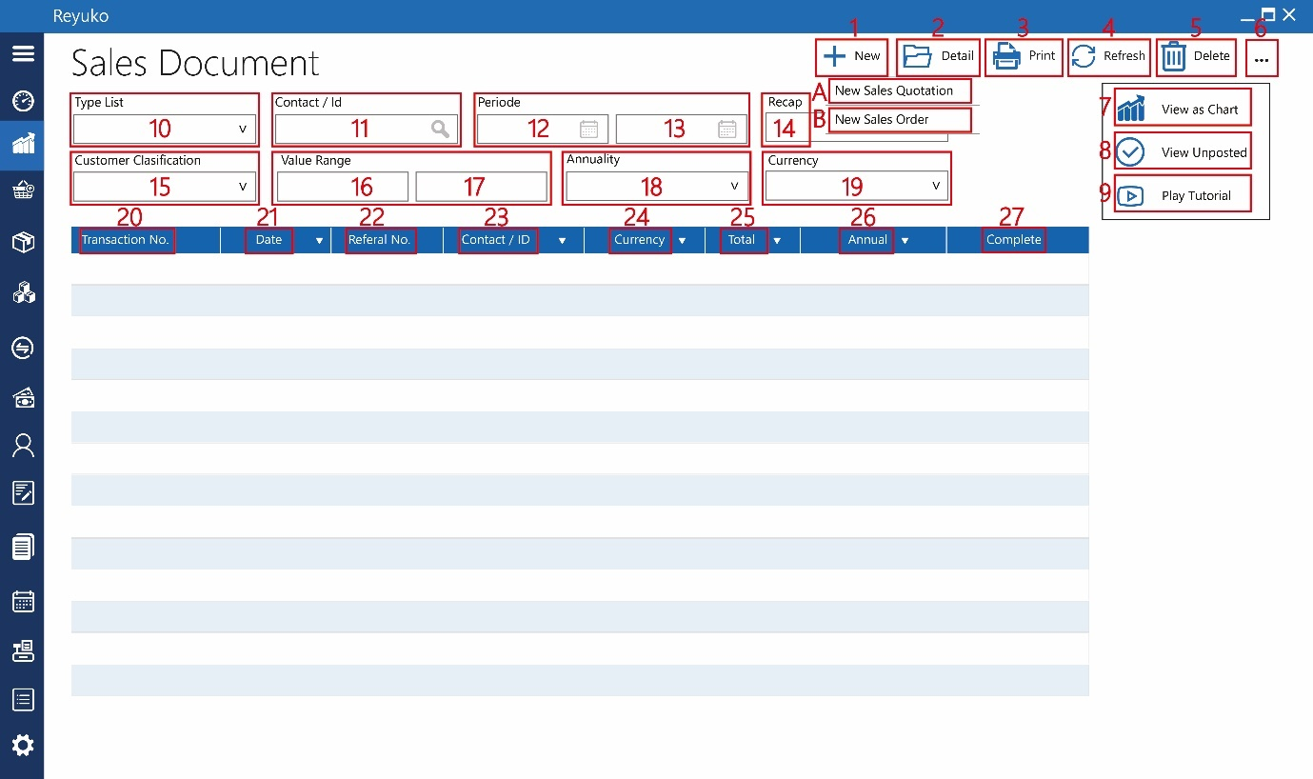

1. Button “new”,
2. New sales quotation
3. New sales order
4. Button “detail”,
5. Button “print”,
6. Button “refresh”,
7. Button “delete”,
8. Button “…”,
9. Button “view as chart”,
10. Button “view unposted”,
11. Button “play tutorial”,
12. Dropdown “type list”,
13. Field “contact/id”,
14. Date picker “start periode”,
15. Date picker “end periode”,
16. Dropdown “recap”,
17. Dropdown “customer clasification”,
18. Field “start value range”,
19. Field “end value range”,
20. dropdown “annuality”,
21. dropdown “currency”,

informasi tabel

1. transaction no. :
2. date :
3. referral no. :
4. contact / id :
5. currency :
6. total :
7. annual :
8. complete :
9. Delivery order :

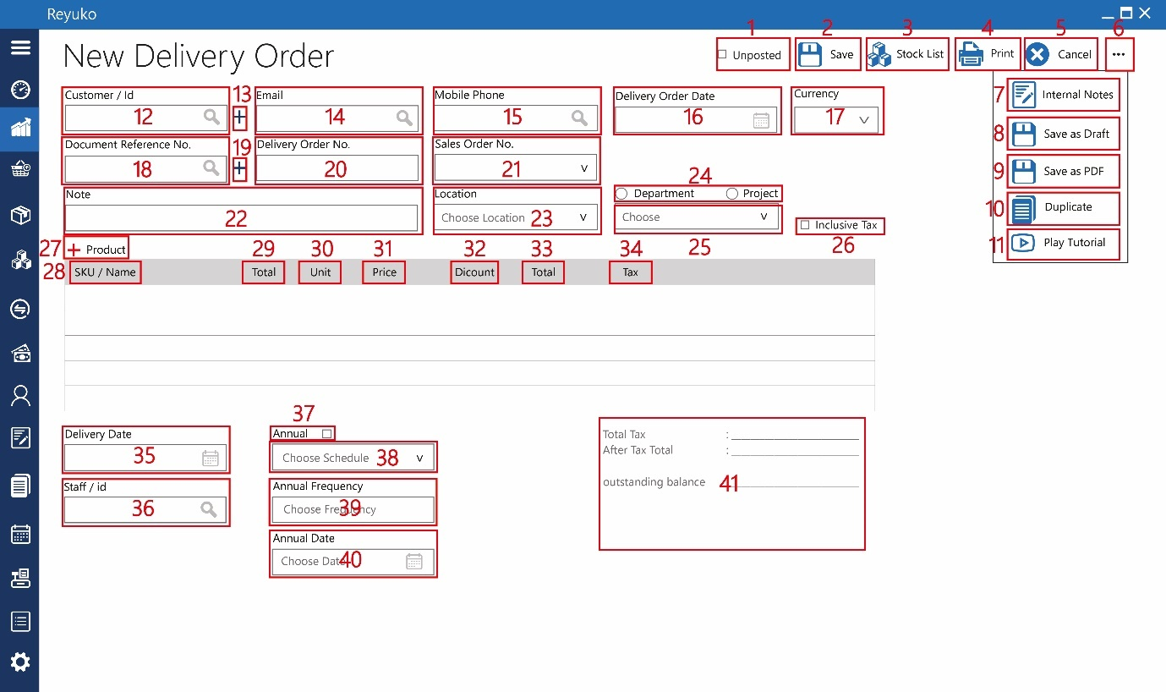

1. Checkbox “unposted”,
2. Button “save”,
3. Button “stock list”,
4. Button “print”,
5. Button “cancel”,
6. Button “…”,
7. Button “internal notes”,
8. Button “save as draft”,
9. Button “save as PDF”,
10. Button “duplicate”,
11. Button “play tutorial”,
12. Field “customer / ID”,
13. Button “+”,
14. Field “email”,
15. Field “mobile phone”,
16. Datepicker “delivery order date”,
17. dropdown “currency”,
18. field “document reference no.”,
19. button “+”,
20. field “delivery order no.”,
21. field “sales order no.”,
22. field “note”,
23. dropdown “location”,
24. radio button “department & project”,
25. dropdown “department / project”,
26. checkbox “inclusive tax”,
27. button “+product”,
28. kolom “SKU/Name”,
29. kolom “total”,
30. kolom “unit”,
31. kolom “price”,
32. kolom “discount”,
33. kolom “total”,
34. kolom “tax”,
35. date picker “delivery date”,
36. Field “staff / id”,
37. Checkbox “annual”,
38. Dropdown “annual”,
39. Field ”annual frequency”,
40. Date picker “annual date”,
41. Detail

|  |  |  |
| --- | --- | --- |
| FIELD TABLE | TABLE | REMARK |
|  | id_DO |  |
|  | id_kode_transaksi |  |
|  | id_transaksi |  |
|  | kode_transaksi |  |
| Delivery Order No. | no_DO |  |
| Customer / Id | id_pelanggan |  |
|  | nama_pelanggan |  |
| Mobile Phone | no_hp |  |
| Email | email |  |
| Sales Order No. | id_order_penjualan |  |
|  | nomor_order_penjualan |  |
|  | id_referal_transaksi |  |
| Currency | id_mata_uang |  |
|  | mata_uang |  |
|  | kurs_tukar |  |
| Delivery Order Date | tanggal_DO |  |
| Document Reference No. | id_no_referensi_dokumen |  |
|  | no_referensi_dokumen |  |
| Location | id_lokasi |  |
|  | Nama_Lokasi |  |
| Note | keterangan |  |
| Project | id_proyek |  |
| Department | id_departemen |  |
| Inclusive Tax | checkbox_inclusive_tax |  |
| Delivery Date | tanggal_pengiriman |  |
| Staff / id | id_petugas |  |
|  | nama_petugas |  |
| Unposted | checkbox_unposted |  |
| Annual | checkbox_berulang |  |
| Choose Schedule | dropdown_berulang |  |
| Annual Frequency | durasi_berulang |  |
| Annual Date | tanggal_berulang |  |
|  | id_akun_persediaan_produk |  |
|  | total_debit_akun_persediaan_produk |  |
|  | total_kredit_akun_persediaan_produk |  |
|  | id_akun_pengiriman_jual_produk |  |
|  | total_debit_akun_pengiriman_jual_produk |  |
|  | total_kredit_akun_pengiriman_jual_produk |  |
|  | total_sebelum_pajak |  |
| Total Tax | total_pajak |  |
| After Total Tax | total_setelah_pajak |  |
| outstanding balance | saldo_terhutang |  |
| Installment/Annual | cicilan_per_bulan |  |
| Installment | durasi_cicilan |  |
| Due Date | due_date |  |
|  | id_user_id |  |
|  | id_periode_akuntansi |  |
|  | real recording time |  |

1. List Delivery Order

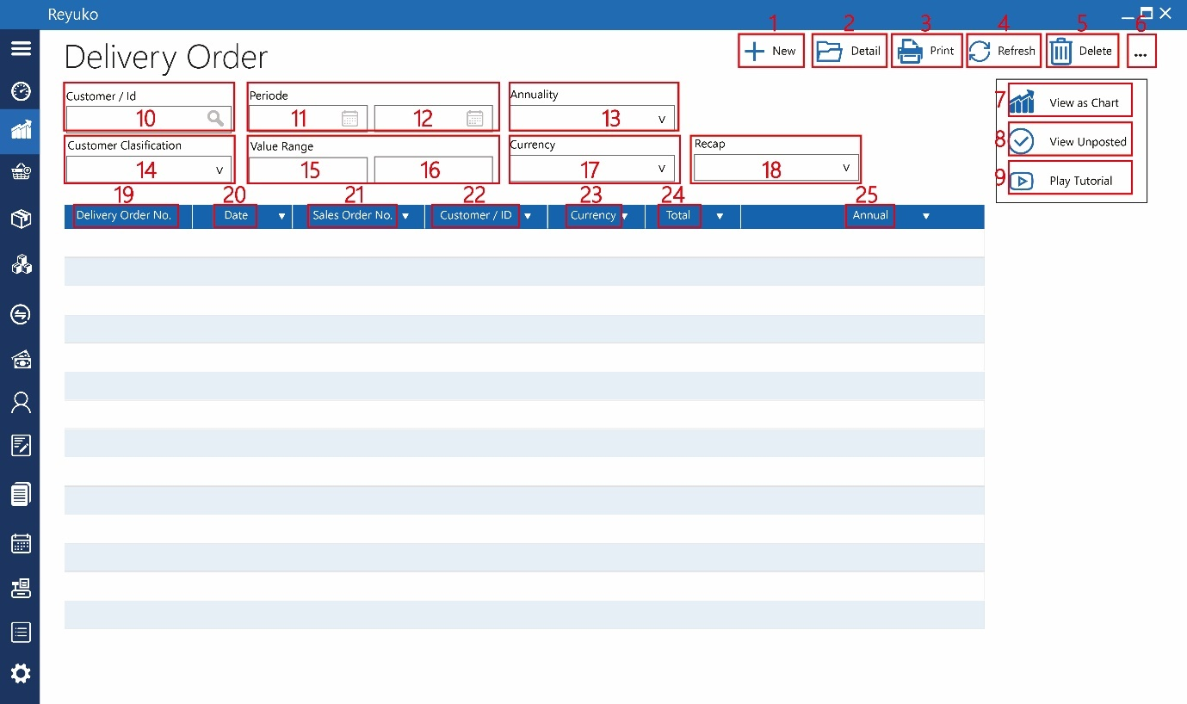

1. Button “new”,
2. Button “detail”,
3. Button “print”,
4. Button “refresh”,
5. Button “delete”,
6. Button “…”,
7. Button “view as chart”,
8. Button “view unposted”,
9. Button “play tutorial”,
10. Field “contact/id”,
11. Date picker “start periode”,
12. Date picker “end periode”,
13. Dropdown “annuality”,
14. Dropdown “customer clasification”,
15. Field “start value range”,
16. Field “end value range”,
17. dropdown “currency”,
18. dropdown “annuality”,

informasi tabel

1. delivery order no. :
2. date :
3. sales order no. :
4. customer / id :
5. currency :
6. total :
7. annual :
8. Invoice

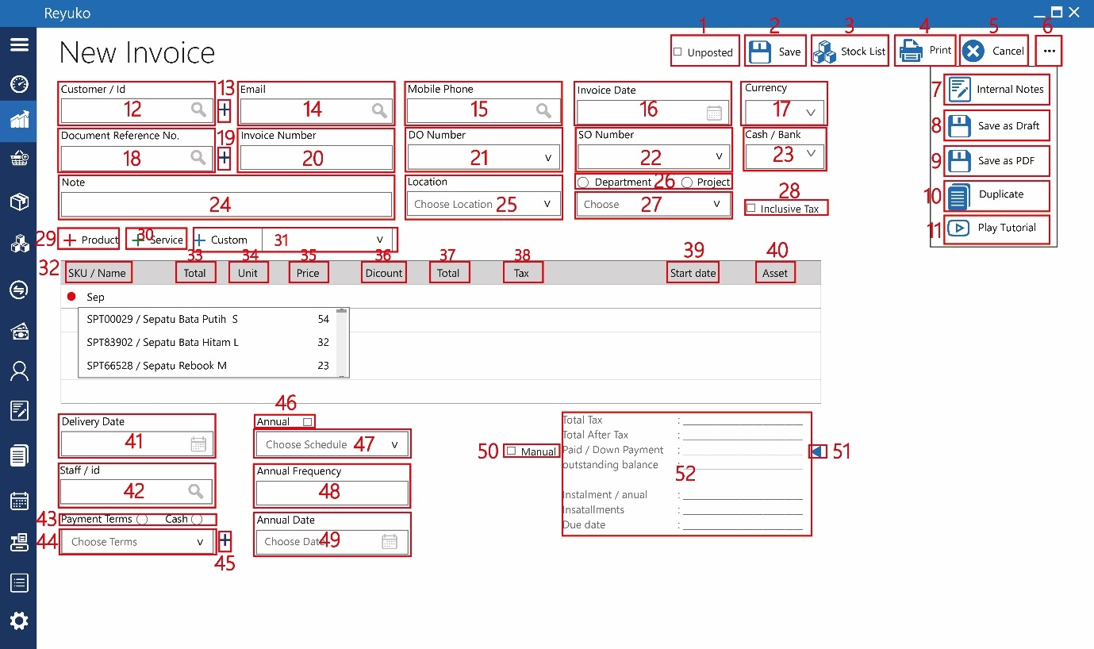

1. Checkbox “unposted”,
2. Button “save”,
3. Button “stock list”,
4. Button “print”,
5. Button “cancel”,
6. Button “…”,
7. Button “internal notes”,
8. Button “save as draft”,
9. Button “save as PDF”,
10. Button “duplicate”,
11. Button “play tutorial”,
12. Field “customer / ID”,
13. Button “+”,
14. Field “email”,
15. Field “mobile phone”,
16. Datepicker “invoice date”,
17. dropdown “currency”,
18. field “document reference no.”,
19. button “+”,
20. field “invoice no.”,
21. field “DO number”,
22. field “SO number”,
23. dropdown “cash/bank”,
24. field “note”,
25. dropdown “location”,
26. radio button “department & project”,
27. dropdown “department / project”,
28. checkbox “inclusive tax”,
29. button “+product”,
30. button “+service”,
31. button & dropdown “+custom”,
32. kolom “SKU/Name”,
33. kolom “total”,
34. kolom “unit”,
35. kolom “price”,
36. kolom “discount”,
37. kolom “total”,
38. kolom “tax”,
39. kolom “start date”,
40. kolom “asset”,
41. date picker “delivery date”,
42. Field “staff / id”,
43. Radio button “payment term & cash”
44. Dropdown “payment term/cash”,
45. Button “+”,
46. Checkbox “annual”,
47. Dropdown “annual”,
48. Field ”annual frequency”,
49. Date picker “annual date”,
50. Checkbox “manual”,
51. Button “uang muka”,
52. Detail

|  |  |  |
| --- | --- | --- |
| FIELD TABLE | TABLE | REMARK |
|  | id_invoice |  |
|  | id_kode_transaksi |  |
|  | id_transaksi |  |
|  | kode_transaksi |  |
| Invoice Number | no_invoice |  |
| Customer / Id | id_pelanggan |  |
|  | nama_pelanggan |  |
| Mobile Phone | no_hp |  |
| Email | email |  |
| SO Number | id_order_penjualan |  |
|  | no_order_penjualan |  |
| DO Number | id_DO |  |
|  | no_DO |  |
|  | id_referal_transaksi |  |
| Currency | id_mata_uang |  |
|  | mata_uang |  |
|  | kurs_tukar |  |
| Invoice Date | tanggal_invoice |  |
| Document Reference No. | id_no_referensi_dokumen |  |
|  | no_referensi_dokumen |  |
| Location | id_lokasi |  |
|  | Nama_Lokasi |  |
| Note | keterangan |  |
| Project | id_proyek |  |
| Department | id_departemen |  |
| Incluvise_tax | checkbox_inclusive_tax |  |
| Delivery Date | tanggal_pengiriman |  |
| Staff / id | id_petugas |  |
|  | nama_petugas |  |
| Unposted | checkbox_unposted |  |
| Payment Terms / Cash | checkbox_tunai/term_pembayaran |  |
| Choose Terms | dropdown_term_pembayaran |  |
| Cash / Bank | dropdown_bank_kas |  |
| Annual | checkbox_berulang |  |
| Choose Schedule | dropdown_berulang |  |
| Annual Frequency | durasi_berulang |  |
| Annual Date | tanggal_berulang |  |
|  | id_akun_harga_pokok_produk |  |
|  | total_debit_akun_harga_pokok_produk |  |
|  | total_kredit_akun_harga_pokok_produk |  |
|  | id_akun_penjualan_produk |  |
|  | total_debit_akun_penjualan_produk |  |
|  | total_kredit_akun_penjualan_produk |  |
|  | id_akun_persediaan_produk |  |
|  | total_debit_akun_persediaan_produk |  |
|  | total_kredit_akun_persediaan_produk |  |
|  | id_akun_pengiriman_jual |  |
|  | total_debit_id_akun_pengiriman_jual |  |
|  | total_kredit_id_akun_pengiriman_jual |  |
|  | id_akun_penjualan_jasa |  |
|  | total_debit_penjualan_jasa |  |
|  | total_kredit_penjualan_jasa |  |
| Custom Account | id_akun_penjualan_custom |  |
|  | total_debit_penjualan_custom |  |
|  | total_kredit_penjualan_custom |  |
|  | id_akun_pajak_produk |  |
|  | total_debit_akun_pajak_produk |  |
|  | total_kredit_akun_pajak_produk |  |
|  | id_akun_pajak_jasa |  |
|  | total_debit_akun_pajak_jasa |  |
|  | total_kredit_akun_pajak_jasa |  |
|  | id_akun_tunai_penjualan |  |
|  | total_debit_akun_tunai_penjualan |  |
|  | total_kredit_akun_tunai_penjualan |  |
|  | id_akun_piutang_penjualan |  |
|  | total_debit_akun_piutang_penjualan |  |
|  | total_kredit_akun_piutang_penjualan |  |
|  | total_sebelum_pajak |  |
| Total Tax | total_pajak |  |
| After Total Tax | total_setelah_pajak |  |
| Manual | Checkbox_Manual |  |
|  | id_referal_SA |  |
| Paid/Down Payment | lunas/dibayar_uang_muka |  |
| outstanding balance | saldo_terhutang |  |
| Installment/Annual | cicilan_per_bulan |  |
| Installment | angsuran |  |
| Due Date | due_date |  |
|  | id_user_id |  |
|  | id_periode_akuntansi |  |
|  | real recording time |  |

1. List Invoice

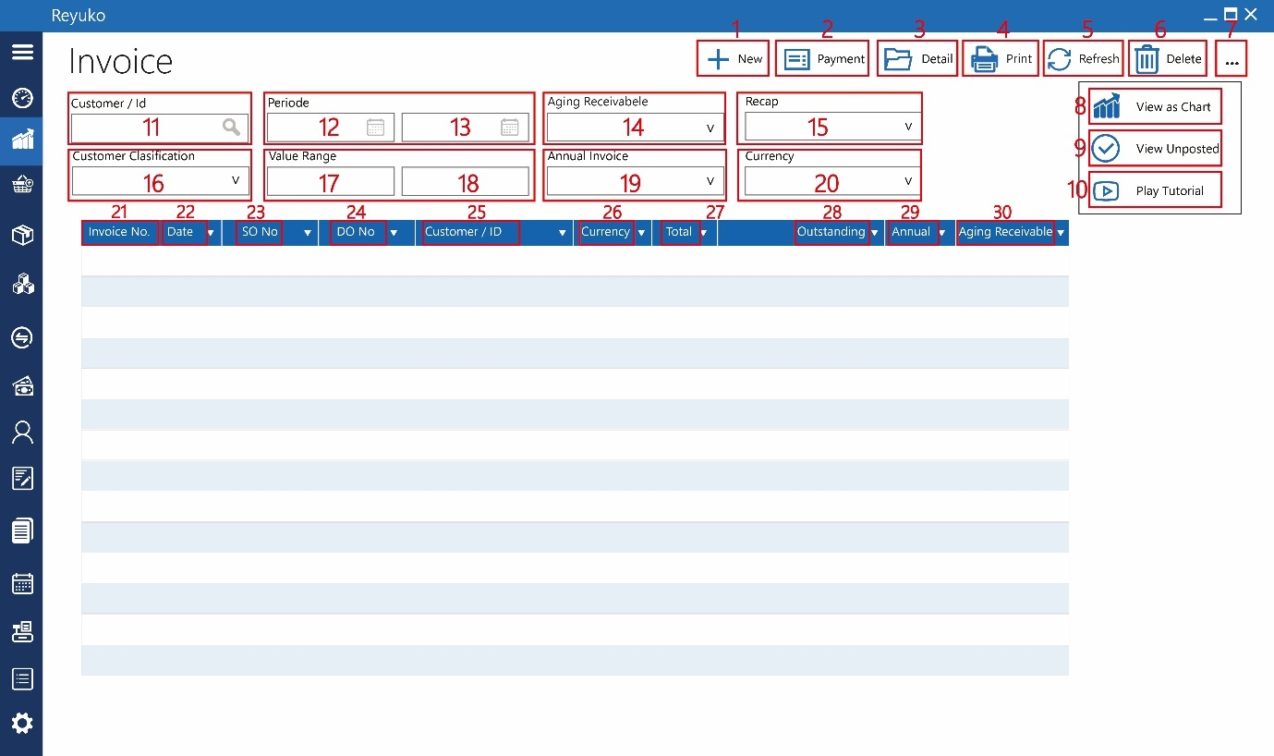

1. Button “new”,
2. Button “payment”,
3. Button “detail”,
4. Button “print”,
5. Button “refresh”,
6. Button “delete”,
7. Button “…”,
8. Button “view as chart”,
9. Button “view unposted”,
10. Button “play tutorial”,
11. Field “customer/id”,
12. Date picker “start periode”,
13. Date picker “end periode”,
14. Dropdown “aging receivable”,
15. Dropdown “recap”,
16. Dropdown “customer clasification”,
17. Field “start value range”,
18. Field “end value range”,
19. dropdown “annual invoice”,
20. dropdown “currency”,

informasi tabel

1. invoice no. :
2. date :
3. SO no. :
4. DO no :
5. customer / id :
6. currency :
7. total :
8. outstanding
9. annual :
10. aging receivable
11. Sales Return

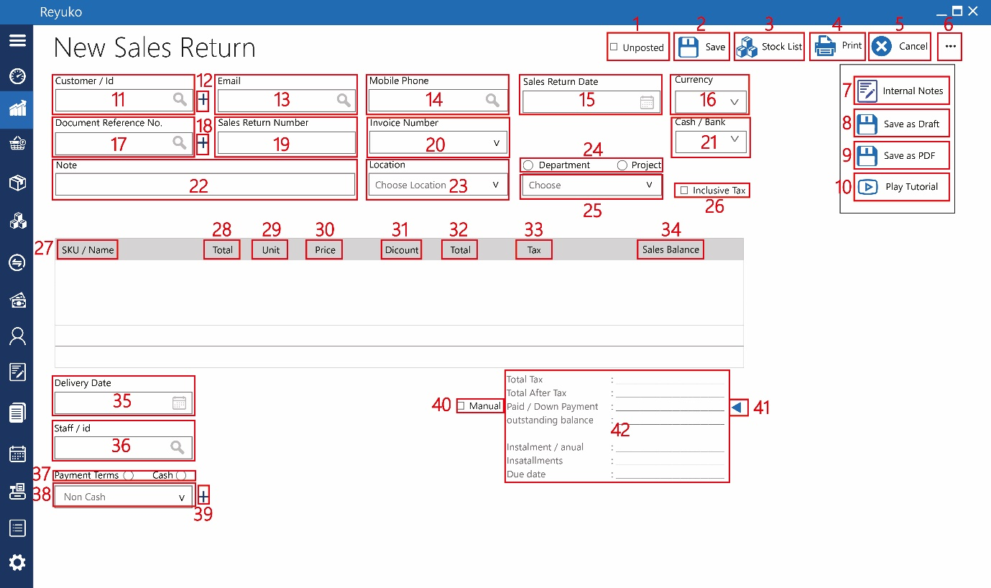

1. Checkbox “unposted”,
2. Button “save”,
3. Button “stock list”,
4. Button “print”,
5. Button “cancel”,
6. Button “…”,
7. Button “internal notes”,
8. Button “save as draft”,
9. Button “save as PDF”,
10. Button “play tutorial”,
11. Field “customer / ID”,
12. Button “+”,
13. Field “email”,
14. Field “mobile phone”,
15. Datepicker “sales return date”,
16. dropdown “currency”,
17. field “document reference no.”,
18. button “+”,
19. field “sales return no.”,
20. dropdown “invoice number”,
21. dropdown “cash/bank”,
22. field “note”,
23. dropdown “location”,
24. radio button “department & project”,
25. dropdown “department / project”,
26. checkbox “inclusive tax”,
27. kolom “SKU/Name”,
28. kolom “total”,
29. kolom “unit”,
30. kolom “price”,
31. kolom “discount”,
32. kolom “total”,
33. kolom “tax”,
34. kolom “sales balance”,
35. date picker “delivery date”,
36. Field “staff / id”,
37. Radio button “payment term & cash”
38. Dropdown “payment term/cash”,
39. Button “+”,
40. Checkbox “manual”,
41. Button “uang muka”,
42. Detail

|  |  |  |
| --- | --- | --- |
| FIELD TABLE | TABLE | REMARK |
|  | id_retur_penjualan |  |
|  | id_kode_transaksi |  |
|  | id_transaksi |  |
|  | kode_transaksi |  |
| Sales Return Number | no_retur_penjualan |  |
| Customer / Id | id_pelanggan |  |
|  | nama_pelanggan |  |
| Mobile Phone | no_hp |  |
| Email | email |  |
| Invoice Number | id_referal_transaksi |  |
|  | no_referensi_transaksi |  |
| Currency | id_mata_uang |  |
|  | mata_uang |  |
|  | kurs_tukar |  |
| Sales Return Date | tanggal_retur_penjualan |  |
| Document Reference No. | id_no_referensi_dokumen |  |
|  | no_referensi_dokumen |  |
| Location | id_lokasi |  |
|  | Nama_Lokasi |  |
| Note | keterangan |  |
| Project | id_proyek |  |
| Department | id_departemen |  |
| Inclusive Tax | checkbox_inclusive_tax |  |
| Delivery Date | tanggal_pengiriman |  |
| Staff / id | id_petugas |  |
|  | nama_petugas |  |
| Unposted | checkbox_unposted |  |
| Payment Terms / Cash | checkbox_tunai/term_pembayaran |  |
| Choose Terms | dropdown_term_pembayaran |  |
| Cash / Bank | dropdown_bank_kas |  |
|  | id_akun_harga_pokok_produk |  |
|  | total_debit_akun_harga_pokok_produk |  |
|  | total_kredit_akun_harga_pokok_produk |  |
|  | id_akun_penjualan_produk |  |
|  | total_debit_akun_penjualan_produk |  |
|  | total_kredit_akun_penjualan_produk |  |
|  | id_akun_persediaan_produk |  |
|  | total_debit_akun_persediaan_produk |  |
|  | total_kredit_akun_persediaan_produk |  |
|  | id_akun_penjualan_jasa |  |
|  | total_debit_penjualan_jasa |  |
|  | total_kredit_penjualan_jasa |  |
|  | id_akun_penjualan_custom |  |
|  | total_debit_penjualan_custom |  |
|  | total_kredit_penjualan_custom |  |
|  | id_akun_pajak_produk |  |
|  | total_debit_akun_pajak_produk |  |
|  | total_kredit_akun_pajak_produk |  |
|  | id_akun_pajak_jasa |  |
|  | total_debit_akun_pajak_jasa |  |
|  | total_kredit_akun_pajak_jasa |  |
|  | id_akun_tunai_penjualan |  |
|  | total_debit_akun_tunai_penjualan |  |
|  | total_kredit_akun_tunai_penjualan |  |
|  | id_akun_piutang_penjualan |  |
|  | total_debit_akun_piutang_penjualan |  |
|  | total_kredit_akun_piutang_penjualan |  |
|  | total_sebelum_pajak |  |
| Total Tax | total_pajak |  |
| After Total Tax | total_setelah_pajak |  |
| Manual | Checkbox_Manual |  |
|  | id_referal_PA |  |
|  | lunas/dibayar_uang_muka |  |
| outstanding balance | saldo_hutang |  |
| Installment/Annual | cicilan_per_bulan |  |
| Installment | angsuran |  |
| Due Date | due_date |  |
|  | id_user_id |  |
|  | id_periode_akuntansi |  |
|  | real reconging time |  |

1. List sales return

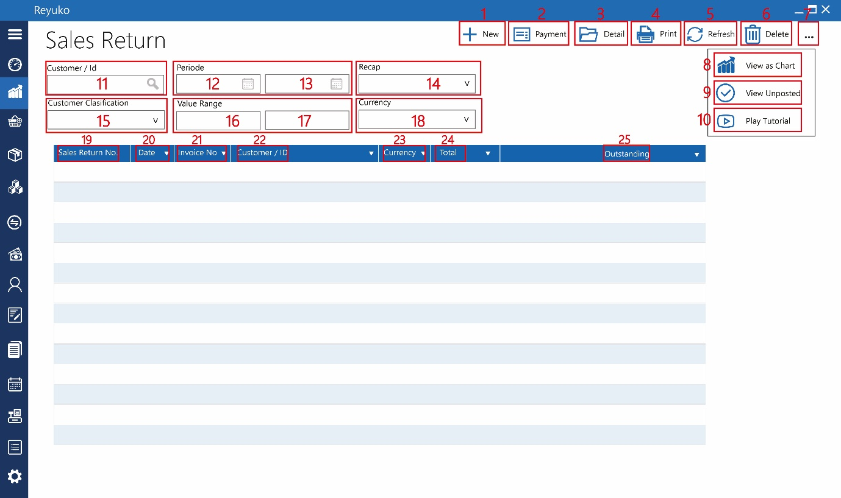

1. Button “new”,
2. Button “payment”,
3. Button “detail”,
4. Button “print”,
5. Button “refresh”,
6. Button “delete”,
7. Button “…”,
8. Button “view as chart”,
9. Button “view unposted”,
10. Button “play tutorial”,
11. Field “customer/id”,
12. Date picker “start periode”,
13. Date picker “end periode”,
14. Dropdown “recap”,
15. Dropdown “customer clasification”,
16. Field “start value range”,
17. Field “end value range”,
18. dropdown “currency”,

informasi tabel

1. sales return no. :
2. date :
3. Invoice no. :
4. customer / id :
5. currency :
6. total :
7. outstanding :